**Pass task 9.1 Sprint 2 Retrospective**

**Meeting Agenda**

Date/Location: 9-May-2019 at 1:30PM in A302

**Sprint Review**

* LL fixed font size and selection in deployment phase
* LL improved game game aesthethic
* AC fixed highscore problems where it wnot save into the txt file
* AC fixed the coordinate bug
* AC improved game aesthehic by changing background image, background music and loading screen image
* MC make the highscore to be able to sort according to the level of difficulty
* LL made the instruction page

**Sprint Retrospective**

* AC had a lot of troubles fixing the highscore bug
* Everyone attended all scrum meetings
* Everyone manage to complete their tasks and overcome all problems during the process
* Marc broke his glasses
* Battleship game looks better and sound better
* It was the last few weeks of the semester so everyone had assignments which causes a tense atmosphere and jeopardize communication a bit.

**Information Updates/Reminders**

* Last week was about adding the extensions and documenting the code
* This week we will do a sprint review of our product and process and also continue adding in any extensions or game bugs that are not done yet
* Help from an external consultant has been provided to help get the code converted and working if that was not done.
* Everyone should have used toggl.com to track their time last week. Also track time on tasks this week with Toggl.
* Tutor must be added to GitHub, Trello and Toggl.
* Slack will be used to show the changes in the Trello board during the sprint of activity
* The Programming Help Desk ATC620 is *still* available to help us with programming for this unit.

**Decisions Needed**

* Create new extensions to extend the features
* Fix any extensions bugs that had occurred

**General Items**

* The Trello board needs to be updated ready for the planned Sprint process. In particular columns for project backlog and sprint backlog will be needed.
* Create and link the team slack so that we can be notified and have a nice record of the Trello updates.
* The project backlog of tasks needs to be created. Use the existing bugs and features we have documented, and convert to the required format. Need a meeting after this meeting to get that done and into Trello (today).
* Project backlog tasks need to be prioritised and their time estimated using 1,2,4,8 hour categories. (Today)
* The new Sprint backlog needs to be pre-selected ready for discussion and approval with the project owner. (Today)
* Once Sprint has started, hold a daily scrum meeting.
* Extensions that are new will be added

**Meeting Minutes**

Date/Location: 9/5/19 at Swinburne University of Technology in A302

Attendees: Marc Chai, Lim Jia Lok, Aldalton Choo

Start Time: [1:30 p.m.]

End Time: [3:30 p.m.]

**Decisions**

* AC will implement cheat mode
* LL will create a timer
* MC will create slider buttons to control the volumne

**Actions**

* 15-5-19 AC should create a cheat mode to give the players the ability to modify certain elements of the game like extra lives and etc.
* 15-5-19 LL should create a timer to restraint the user to choose a tile immediately within that time limit
* 8-5-19 Marc should create sliders to control the volume so that the value of the sound can be control from 0 to 100.

Scrum meeting



Figure (1) Scrum meeting 18 9th May 2019



Figure (2) Scrum meeting 19 10th May 2019



Figure (3) Scrum meeting 20 11th May 2019



Figure (4) Scrum meeting 21 12th May 2019



Figure (5) Scrum meeting 22 13th May 2019



Figure (6) Scrum meeting 23 14th May 2019

What I done this week

For this week I implemented the cheat mode for the player to use when they have difficulty beating the game. All they must do is press the button key ‘h’ and the position of the AI ships will appear on the board. Figure (7) is an example of how the cheat mode looks like.

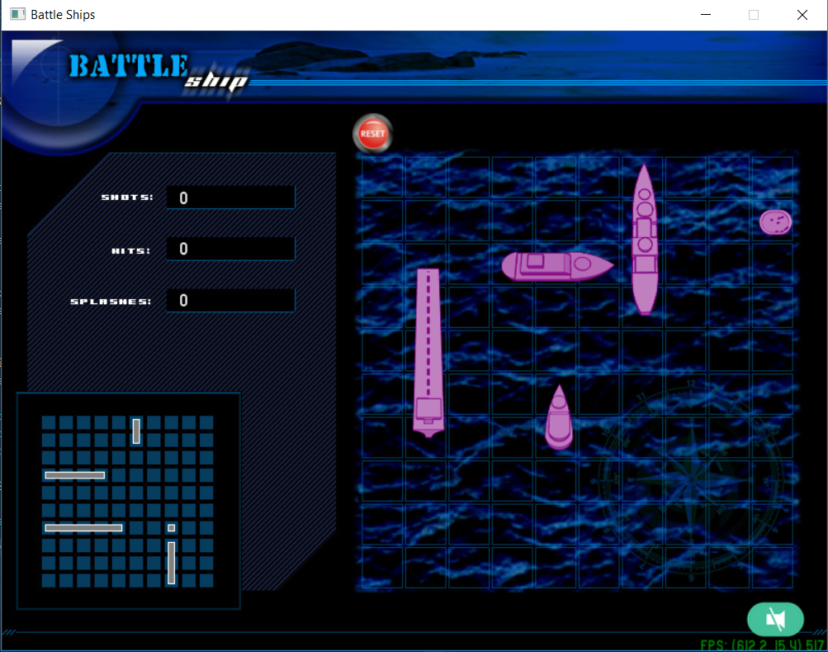

Figure (7) Cheat mode for battleship

I added a new line of code in the DiscoveryController class so that when the player clicks the key button ‘h’ the AI ships position will be revealed. Figure (8) is an example of how the line of codes looks like.



Figure (8) Implementing the line of code for cheat mode in DiscoveryController class.

GitHub contributor graph and network graph

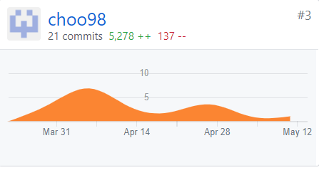

Figure (9) Contributions graph for Aldalton Choo

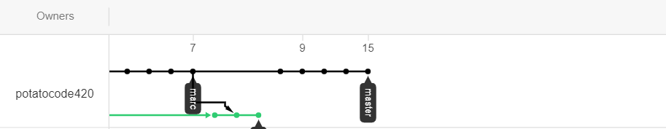

Figure (10) Network graph for Aldalton Choo

Toggl Board

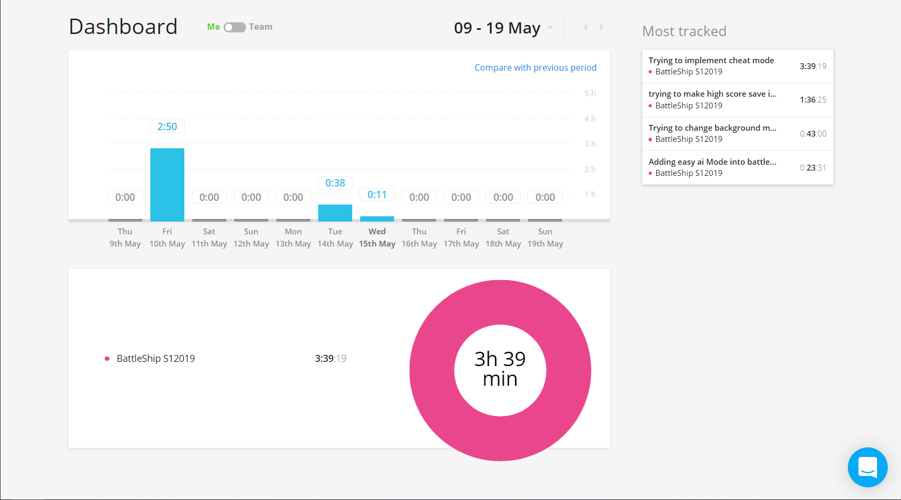

Figure (11) Toggl Board for Aldalton Choo

Trello Board

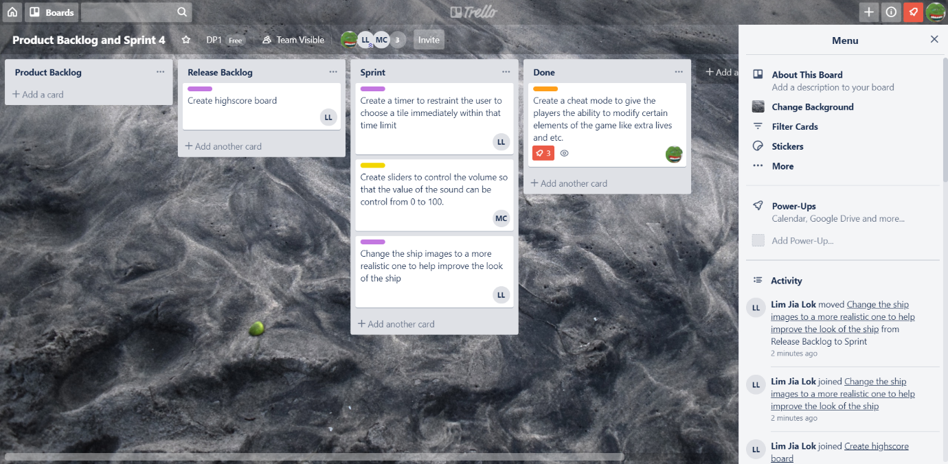

Figure (12) Trello board for Aldalton Choo